**Squish Rasters and Polygon Toolbox for ArcGIS 10.7**

Thomas Dilts  
10/6/2021  
Great Basin Landscape Ecology Lab  
Department of Natural Resources and Environmental Science  
University of Nevada Reno

**Introduction**

Rasters that are separated into multiple areas of interest with large gaps in between can be difficult to display cartographically. Usually we wish for the map reader to be able to detect subtle patterns while at the same time allowing them to view the entire dataset. Cartographers frequently rely on inset maps that remove a portion of the map area from its true location and projects it onto a new false location in order to increase the map scale (cartographic map sale not study extent) and increase the amount of detail that can be seen on the map.

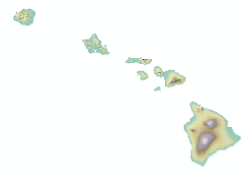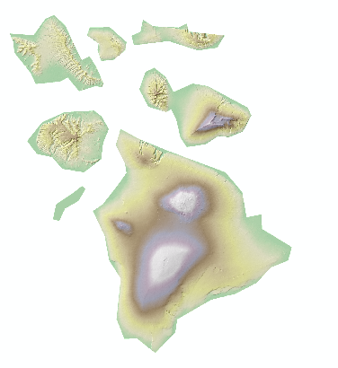

Figure 1: By taking the Hawaiian Islands and moving them cartographically we can increase the amount of detail on our map by roughly 5.5 times.

This tool allows the user to take an original and an edited shapefile and move the raster cells associated with those polygons.

**Inputs**



The toolbox is designed to run in ArcGIS Desktop (ArcMap) version 10.7 and hasn’t been tested yet in ArcGIS Pro. My experience is that most models will transfer to ArcGIS Pro with few issues. The toolbox has two main tools designed to run in sequence. The Get Displacement for Each Polygon tool identifies the shifts in X and Y coordinates (I recommend using projected data) that will be needed to move each polygon. It also creates a blank raster called Squished.tif that the new results will be written to.

The second tool called Clip Raster to Polygon takes an input raster (in the example above Hawaiian Island DEM) and iterates through each feature/polygon clipping the raster and shifting the cells to their new location. Finally, the results are written back to Squished.tif.

The final post-processing step the user choose to run the Extract by Mask tool to “clip” their new raster to the edited shapefile. This is done outside of this tool.

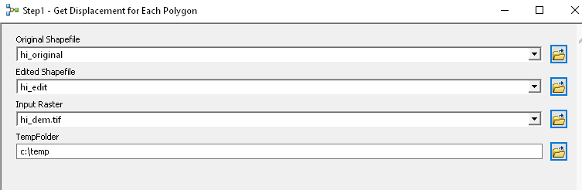

The inputs for this tool are the original shapefile and the edited shapefile in which the locations of the polygons have been moved. You’ll need to perform the editing prior to running this tool. The third input is an input raster of your choosing. Finally, a folder for storing temporary files is required. I recommend something simple like c:\temp provided that it has no or few files in it. The example below shows the original Hawaiian Islands shapefile in black and the seven largest islands in red after being shifted. The Big Island (Hawaii) wasn’t moved.

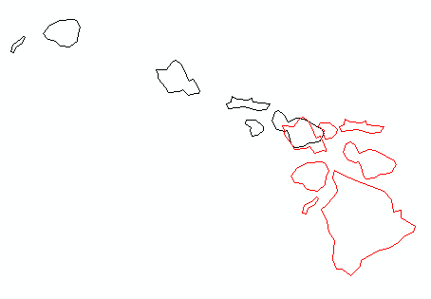

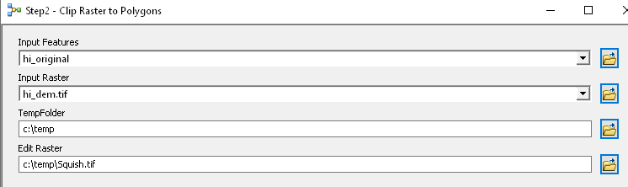

The second tool – Clip Raster to Polygon – uses the same inputs as the first, the input polygons, the input raster, and the folder for temporary files. It also adds the location of the edit raster which is derived from the previous step, is located in the previous step’s temporary folder, and is named Squish.tif. In the Hawaiian example Squish.tif has values of zero outside of each island (see below left). In order to get it to look like map below and on the right we can run the Extract by Mask tool in the Spatial Analyst Toolbox to “clip” the raster to the edited shapefile.

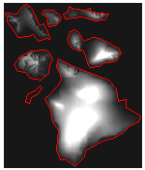

**How the tools work**

The tools were built in ArcGIS ModelBuilder and therefore no code is needed. However, most models can be exported to python script if needed for further development. In addition to running the tools in GUI mode you can also open them up in ModelBuilder for further customization by right-clicking on the model in ArcToolbox and selecting Edit.

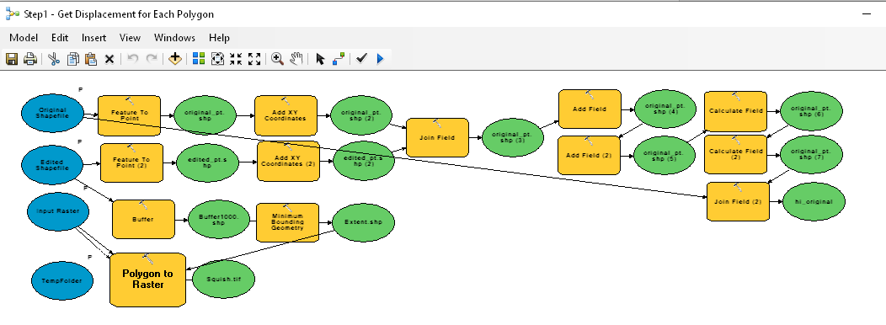

Get Displacement for Each Polygon takes both the original and edited shapefile and creates centroid points for each. We add XY coordinates for each and then calculate the X and Y shift. Finally, that information is joined back to the original shapefile adding two new fields called ShiftX and ShiftY. A second step is that the edited shapefile is buffered by 1000 meters (you may wish to customize this distance yourself) and a single envelope polygon is drawn around the entire buffered shapefile. That envelope is given a placeholder value to zero for every cell.

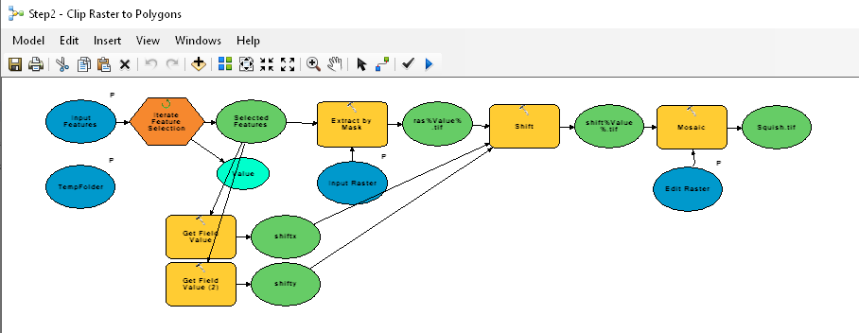

The Clip Raster to Polygon iterates through all of the features in the original shapefile. For each polygon it clips the raster and then shifts it by the specified x and y offset. Finally, each shifted raster is mosaicked onto Squish.tif, which was created in the previous step.